**BARBERSHOP BOOKING WEB-BASED APPLICATION**

**ADM NO: SC211/0709/2018**

**NAME: MALUKI TONY NDEREVA**

**TEL NO :0714444593/0112154469**

**E-MAIL ADDRESS: Tonymaluki@gmail.com**

**DEGREE PROGRAM: BACHELOR OF SCIENCE (INFORMATION TECHNOLOGY)**

A project proposal submitted in partial fulfilment of the requirements for the award of Bachelor of Information Technology at the School of Computing and information Technology, Muranga University of Technology

**DECLARATION AND APPROVAL**

I Maluki Tony Ndereva, declare that this proposal is my original work and has not been presented or forwarded to any other additional party for any kind of award or any kind of qualification

NAME: ______________________________

SIGNATURE: _________________________

DATE: _______________________________

I confirm that this(my) proposal has been exclusively submitted to Lecturer _________________________ under the school of computing and IT in Murang’a University of Technology.

NAME: ________________________________________

SIGNATURE: ___________________________________

DATE: _________________________________________

**DEDICATION**

I dedicate this work to my parents and especially my sibling, Trina Mawia Maluki for giving me emotional support and encouragement to push and work hard to make this project a great success.

**ACKNOWLEDGEMENTS**

I must particularly acknowledge the invaluable contribution of my former internship supervisor, Mr. Emmanuel Kipkosgei Rono.

He took time to find appropriate research directions and constructively criticize every approach before adoption. My family members have been particularly supportive. They have not ceased to shower on me their gracious prayers and moral advice.

**ABSTRACT**

Personal hygiene, general grooming has been an essential and key element in how we interact with each other in our everyday human life.

Keeping a good hygiene and grooming enables us humans to have a higher self-esteem in our working areas, public places, generally in any human interaction.

However, grooming and hygiene is just like any other want/need, it is a service which must be acquired from another individual in exchange for other goods or services or cash.

These individuals also undergo grooming techniques and training to acquire the knowledge and skills to give these services and afterwards, they open a barbershop where clients would then come over to receive these services from them. These grooming services include shaving, facial washing, scrubbing, massages, nail trimming, polishing among others.

After they get these services, they pay for the services.

However, there occur many challenges such as barbershop congestion, time wasting and time inconveniences both the clients and the barbers will encounter and this project seeks to resolve these challenges they encounter.

Table of Contents

**DECLARATION AND APPROVAL** 1

**DEDICATION** 2

**ACKNOWLEDGEMENTS** 3

**ABSTRACT** 4

CHAPTER 1: INTRODUCTION 7

1.1 Background to the study 7

1.2 Problem Statement 7

1.3 RESEARCH OBJECTIVES 8

1.3.1 General Objectives 8

1.3.2 Specific Objectives 8

**1.4 Justification** 8

CHAPTER TWO: LITERATURE REVIEW 10

2.1 Introduction 10

2.2 Existing barbershop booking systems 10

2.3 Requirement gathering and Analysis techniques 12

2.3.1 User requirements 12

2.3.2 Functional requirements 12

2.3.3 Nonfunctional requirements 12

2.4 System Design Techniques 13

2.4.1 UML Diagrams 13

2.5 System Development Techniques / technologies 14

2.5.1 XAMPP/LAMPP 14

2.5.2 React JS 14

2.5.3 Apache 14

2.6. System Testing Techniques 14

2.6.1 Unit testing 14

**3.0 CHAPTER THREE: METHODOLOGY** 16

3.1 Introduction 16

3.2 SYSTEM ANALYSIS 16

3.2.1 FEASIBILITY STUDY 16

3.2.2 Operational Feasibility 16

3.2.3 Technical Feasibility 16

3.2.3 Economic Feasibility 16

3.2.4 Schedule Feasibility 17

**3.3 DEVELOPMENT METHODOLOGY** 18

3.3.1 DATA GATHERING 19

3.3.2 INTERVIEWS 19

**3.4 DESIGN PHASE** 19

3.4.1 USE CASE 20

3.4.2 USE CASE 20

**3.5 SYSTEM DESIGN** 20

**3.5.1 REQUIREMENT ANALYSIS** 20

**3.5.2 FLOW CHART** 21

**3.5.3 LOGIN FLOWCHART** 21

**3.5.4 REGISTRATION FLOWCHART** 22

**3.5.5 BOOKING FLOWCHART** 23

3.6 DATABASE DESIGN 23

3.6.1 ENTITY RELATIONSHIP DIAGRAM 23

3.7 USER INTERFACE DESIGN 23

3.7.1 LOGIN DESIGN 23

3.7.2 REGISTRATION DESIGN 24

3.7.3 BOOKING INTERFACE 25

**3.8 IMPLEMENTATION AND TESTING** 27

**3.8.1 RESOURCES** 27

**3.8.2 CHOICE OF PROGRAMMING TOOLS AND TECHNIQUES** 27

**3.8.3 TEST CASE** 27

**3.9 INTEGRATION** 28

**4.0 CHAPTER 4: DISCUSSION AND CONCLUSION** 28

**4.1 ACHIEVEMENTS** 28

**4.2 CONSTRAINTS** 28

4.3 CONCLUSION 29

CHAPTER 1: INTRODUCTION

1.1 Background to the study

- In any ideal society, personal hygiene and grooming is an essential commodity for all genders, both male and female, and it plays a very important role in our society in terms of how we, the society, view each other according to how we present ourselves in our day to day life.

-Therefore, due to this need in the society, I saw an income making opportunity to deliver these grooming services to the rest of the society.

-Among these services is male and female facial and shaving services which the barbershops would offer these services to the relevant customers, stationed at the relevant barber shops.

- After these services have been offered, the customer pays for the services in the form of cash.

1.2 Problem Statement

- Getting these services however sometimes has been a problem to clients.

- When a client goes to get these services, he may encounter several other customers in line waiting for the same services.

-This leads to excessive time wastage at the queue for both the client and the barber. Also, this leads to loss of revenue for the barber since the client may get tired of waiting in the queue and decide to seek the service at another barbershop.

- Also, the customer is required to pay for the service via tangible money which is a risk factor for being robbed of cash or generally the tangible money getting lost.

-Furthermore, the client may also visit the barbershop and find that the barber has already closed the shop or has not opened the shop on that day, this will just frustrate the client since he/she has travelled all the way just to not get the services he wanted and hence wasting time

1.3 RESEARCH OBJECTIVES

1.3.1 General Objectives

- To develop a barbershop e commerce web-based application

1.3.2 Specific Objectives

1. to analyze existing web-based barbershop booking apps and check if any improvement can be implemented

2. design the user interface and user experience for both client-side and admin-client side

3. develop a fully secured and functioning database management system, client user interface, admin site, an API system to communicate between front-end and the database.

4. Implementation and testing of the final application product for any bugs and system errors

**1.4 Justification**

The purpose of this project is to develop a barbershop booking web-based application that will transform the whole barbershop sector whereby clients will be able to browse ,book for the shaving services they need, schedule for the appropriate time for the service and pay for it online via the booking application.

-When the scheduled time comes, the barber gets all the necessary tools needed for the shave and visits the clients at his /her premises to deliver the service.

**1.5 Scope of the study**

- The system is a web-based barbershop booking application for use by clients needing shaving services.

- With the help of this system, the system will allow clients to visit the site, view the various shaving services offered by the barber, view the various barbers attendants available, book for a shaving session, schedule the date, time and place, and pay for it online using the modern payment methods eg,credit,debit cards, wire transfer, paypal merchants etc.

-A simple well-designed interface will be in place making it easy for the customer to navigate through the site.

-A database will also be available to store all the customers confidential details such as payment methods, phone numbers, addresses, history of purchase of services.

-This database will also enable the admin to view the bookings made on a certain day or week.

CHAPTER TWO: LITERATURE REVIEW

2.1 Introduction

- This chapter describes the research and reviews on barbershop booking systems applications that have been carried out by other researchers. Different methods and techniques used by these researchers in terms of software will be discussed.

-This system is going to integrate various modules for easy and efficient performance.

2.2 Existing barbershop booking systems

There are similar systems that have been developed to handle booking of services from a barbershop. There are also barbershops that have developed their own systems to carry out this task. The following are some of the systems developed:

*Waffor:*

Waffor is a retail focused software product company providing a cloud-based customer engagement & retention marketing solution for retailers to identify, reward and retain customers for faster growth. Their goal is to ensure that every retailer should be able to engage their customers in the most relevant ways that results in successful customer retention. Waffor’s mission is to provide an end-to-end online platform for retailers to create long lasting loyal customers. Some of its features include: Appointment booking, billing, marketing, analytics and more. The software consists of the standard package which is $90 per month and the premium package which is $120 per month. Their services can be accessed through the website [www.waffor.com](http://www.waffor.com/).

*Belliata:*

Belliata believes finding the perfect hair or beauty venue should not be difficult and as the Internet evolves this is becoming more and more difficult for consumers to have unbiased feedback. Their key passion is to help raise the customer experience and quality standards within the beauty sector through gaining the right insight from consumers and being an enabler for this to happen. The features of this system include: Staff scheduling, online booking, appointment reminders, customer tracking and more. The software is free but if you are willing to get extra features you need to pay an extra cost at the rate of $5 per team member. Their services can be accessed from the website [www.belliatasalonsoftware.com](http://www.belliatasalonsoftware.com/).

*Vagaro:*

Vagaro makes it easy to schedule clients, market your barber shop, get booked online, send automatic reminders, manage packages & process payments - on any device. Vagaro's powerful barber software enables you to spend less time on the phone or answering emails. Simply watch bookings roll in. Your clients can book you from any device using the Vagaro App or website. Its features include: Online booking, customer tracking, marketing, payment processing and more. Their services can be accessed through the website [www.vagaro.com](http://www.vagaro.com/).

*Salon Iris :*

Salon Iris is a barbershop software for booking management and marketing. Salon Iris software for barber shop helps strengthen existing client relationships

while building ties with new customers. Their booking, management, and marketing capabilities make it easy to run your shop while focusing on what you do best: taking care of clients. The features of the system include appointment booking, credit card processing, automated marketing, client management, payroll and more. Their pricing comes in different packages, which are basic, deluxe, premier, professional and all in one each ranging at different prices. Their services can be accessed through the website [www.saloniris.com](http://www.saloniris.com/).

*Simplybook.me:*

SimplyBook.me offers the most extensive online booking system on the market for barber shops, one that makes you look professional and solves all your online needs. Manage your business with one solution; website, accept bookings, marketing initiatives, business statistics and online payments. The features of the system include: Scheduling, admin & statistics, booking, email & SMS reminders, accepts payment, calendar sync and many more. The software consists of different packages. These are the free package, basic package which is $9.90 per month, standard package which is $29.90 per month, premium package which is $59.90 per month. The different packages have different features. Their services can be accessed through the website [www.simplybook.me](http://www.simplybook.me/).

The current existing barber booking systems have the following features in common: Appointment booking, appointment reminders, online payments and client management. The proposed system will have an extra feature that enables clients to choose whether they would prefer “at home service” meaning, the barber will have to visit the client at his place to shave him or, at the barber shop.  The existing systems also don’t work in Kenya, the proposed system will be based in Kenya to serve Kenyans. The payment methods available on the existing systems are PayPal and credit card. My proposed system will also

include an M-PESA daraja API payment gateway to enable clients to pay for services easily.

2.3 Requirement gathering and Analysis techniques

2.3.1 User requirements

Requirements specification involves building a system which has the following capabilities:

a) Great user design

b) Great user front user interactivity and functionality

c)easy to find specific pages and contents

2.3.2 Functional requirements

- This are the requirements which the system is expected to meet in terms of functionalities and according to the specific objectives which the system is expected to achieve/deliver:

a) Define the problem at hand

b) Gather system requirements

c)Design the system

d)User sign up/sign in and management

e) Real device testing

f) Implementation

2.3.3 Nonfunctional requirements

- This are requirements attributes which does not address the core functionality of the system, but are also fundamental requirements which the system must address e.g.:

a) security of the system

b) performance

c) scalability

d)reliability

2.4 System Design Techniques

2.4.1 UML Diagrams

- A UML diagram which serves the purpose of visually representing the relationship between various system components, how the system works correspondingly to other systems, or how keys in a database relate to each other.

2.4.1.1 Use-Case Diagram

- It is a representation of a user's interaction with the system that shows the relationship between the user and different use cases in which the user is involved.

2.4.1.2 Activity Diagram

- When the user (client) logs into the system, he is met by a good-looking and appealing home page decorated with beautiful cover photos of various haircuts and services offered.

-The user then browses various barber services available in the catalogue.

-After that, the user selects an appointment date to which the barber will attend to him /her as they desire.

-The user selects the specific services he wants together being the total prices shown by the system

-The user then has a choice of logging in into the system with his account or signing up a new account or alternatively fast checkout with a valid email address.

-The user goes to the next page whereby he is required to choose payment method, e.g. cards, PayPal, mpesa or even pay on delivery of service.

- After successfully booking an appointment, the user gets a confirmation email that the booking was done successfully.

2.5 System Development Techniques / technologies

2.5.1 XAMPP/LAMPP

XAMPP is a free and open source cross-platform web server stack package. The main tools that contain it are Apache HTTP Server, MySQL database and interprets for scripts written in PHP and Perl programming languages. XAMPP is an easy to install Apache distribution containing MySQL, and PHP

2.5.2 React JS

- This is a JavaScript library for building user interfaces.

-React makes it painless to create interactive UIs. Design simple views for each state in your application, and React will efficiently update and render just the right components when your data changes.

-Build encapsulated components that manage their own state, then compose them to make complex UIs.

2.5.3 Apache

Apache is a software foundation that creates and provides web servers software as open source software. HTTP server which is the most popular HTTP server in use today is their main product. This service is totally free for download and use.

2.6. System Testing Techniques

2.6.1 Unit testing

- This is a test whereby it involves testing each module if they are working correctly.

-In this system, I tested each of the system components, for example:

I) payment system to check if all payment methods were working correctly

ii) booking system to check if the database registers the correct details about the customer

iii) The API system to check if it linked and communicated well between the front end and the database.

iv) The mail chimp system to check if it was sending promotional emails and booking emails to customers.

v) The security of the system to check if the system would be vulnerable to malicious attacks by hackers.

|  |  |  |  |  |
| --- | --- | --- | --- | --- |
| **Type of testing** | **Module** | **Objective** | **Expectation** | **Outcome** |
| Unit testing | Payment system | To check if all the integrated payment methods are working successfully | A client should be able to successfully complete payments using any of the provided payment methods | Successful |
| Unit testing | Booking System | To check if the client can be able to book appointments successfully | A client should be able to book his appointment successfully | Successful |
| Unit testing | API system | To check if the front-end client side can be able to update, delete, create in the database and vice-versa | The front-end should be able to effectively communicate to the backend side effectively | Successful |
| Unit testing | Mail Chimp system | To check if the mail chimp system is able to send promotional emails to clients and booking emails | The mail chimp system should be able to send a receipt email in confirmation of the book appointment | Successful |

**3.0 CHAPTER THREE: METHODOLOGY**

3.1 Introduction

- This section includes an in-depth explanation of the whole process of the system analysis, design of the project, testing and implementation of the whole system.

3.2 SYSTEM ANALYSIS

System analysis is the process of collecting and interpreting facts, identifying the problems, and decomposition of a system into its components. System analysis is conducted for the purpose of studying a system or its parts in order to identify its objectives. It is a problem-solving technique that improves the system and ensures that all the components of the system work efficiently to accomplish their purpose.

3.2.1 FEASIBILITY STUDY

Feasibility study is the measure of how beneficial or practical the development of an information system will be to an organization.

3.2.2 Operational Feasibility

Operational feasibility is a measure of how well the solution will work in the organization. It is also a measure of how people feel about the system. Clients have been wasting a lot of time in barbershops by queuing while waiting for services. This proposed system will reduce the time clients have to wait to get served and also help them find their favorite barbers to serve them.

3.2.3 Technical Feasibility

Technical feasibility is a measure of the practicality of a specific technical solution and the availability of technical resources and expertise. The proposed system is to be a web application that users can access on their mobile web browsers or a PC.  Development is to be done with visual studio code which is the official integrated development environment (IDE) for web application development. Knowledge in HTML, CSS, and JavaScript are the core skills required to build the system.

3.2.3 Economic Feasibility

Economic feasibility is the measure of the cost-effectiveness of the proposed system in terms of building the system and the returns after the system is complete and functional. There were a few purchases required in the development of the system. Most of the tools used during development are open source and do not require any form of payment. However, the system will  require a hosting server for users to access the system.

3.2.4 Schedule Feasibility

Schedule Feasibility is defined as the probability of a project to be completed within its scheduled time limits, by a planned due date. The project has been allocated nine weeks for completion which is adequate enough. Below is a Gantt chart to show the project schedule:

|  |  |  |  |  |  |  |  |  |  |  |
| --- | --- | --- | --- | --- | --- | --- | --- | --- | --- | --- |
|  | **ACTIVITY** | Week 1 | Week 2 | Week 3 | Week 4 | Week 5 | Week 6 | Week 7 | Week 8 | Week 9 |
| 1 | **FACT FINDING** |  |  |  |  |  |  |  |  |  |
| 1.1 | Proposed Project Idea |  |  |  |  |  |  |  |  |  |
| 2 | **ANALYSIS** |  |  |  |  |  |  |  |  |  |
| 2.1 | Project Schedule |  |  |  |  |  |  |  |  |  |
| 2.2 | Requirements Analysis |  |  |  |  |  |  |  |  |  |
| 2.3 | DFDs and Process descriptions |  |  |  |  |  |  |  |  |  |
| 2.4 | Use case diagrams |  |  |  |  |  |  |  |  |  |
| 2.5 | Entity relationship diagram |  |  |  |  |  |  |  |  |  |
| **3** | **DESIGN** |  |  |  |  |  |  |  |  |  |
| 3.1 | System architectural design |  |  |  |  |  |  |  |  |  |
| 3.2 | User interface design |  |  |  |  |  |  |  |  |  |
| 3.3 | Database design |  |  |  |  |  |  |  |  |  |
| 3.4 | Structure chart |  |  |  |  |  |  |  |  |  |
| **4** | **DEVELOPMENT AND TESTING** |  |  |  |  |  |  |  |  |  |
| 4.1 | Do coding |  |  |  |  |  |  |  |  |  |
| 4.2 | Do testing |  |  |  |  |  |  |  |  |  |

Figure 1: project schedule Gannt chart

**3.3 DEVELOPMENT METHODOLOGY**

The waterfall methodology will be employed in the development of the system. The waterfall Model illustrates the software development process in a linear sequential flow. This means that any phase in the development process begins only if the previous phase is complete. In this waterfall model, the phases do not overlap.

The following illustration is a representation of the different phases of the Waterfall Model.

Figure 1: waterfall Development Methodology

1. **Requirement analysis -** All possible requirements of the system to be developed are captured in this phase and documented in a requirement specification document.

1. **System Design -** The requirement specifications from the first phase are studied in this phase and the system design is prepared. This system design helps in specifying hardware and system requirements and helps in defining the overall system architecture.

1. **Implementation -** With inputs from the system design, the system is first developed in small programs called units, which are integrated in the next phase. Each unit is developed and tested for its functionality, which is referred to as Unit Testing.

1. **Testing -** After designing and building the system, the system will be tested and debugged to ensure it has minimal or no flaws.

1. **Deployment -** Once the functional and non-functional testing is done; the product is deployed in the customer environment or released into the market.

1. **Maintenance -** Maintenance is done to fix issues that come up in the client environment through releasing updates or patches. Better versions of the system are also released to improve on the quality.

**Reasons for choosing Waterfall Methodology**

1. Simple and easy to understand and use
2. Phases are processed and completed one at a time, hence there is no overlapping in phases.
3. It is easy to arrange tasks.
4. Easy to manage due to the rigidity of the model.

3.3.1 DATA GATHERING

This is the formal process of using various techniques to collect information about problems, requirements and preferences about the proposed system. Various techniques were used to gather information on the current barbershop system in the market operates and their daily routine. The following data gathering techniques were used:

3.3.2 INTERVIEWS

Barbers and clients from various barbershops were interviewed. The main objectives of the interviews were:

1. To find out how barbers get clients.
2. To find out how barbers manage their clients.
3. To know the schedule of the barbers.
4. To find out how clients book for services.
5. To find out how barbers’ market themselves.

Barber said that they get clients by waiting for them to walk into their barbershops and request for services. Some barbers complained about how it is difficult to get clients sometimes and they can even go for hours before a client shows up at the barbershop. Most barbers stated that they open at 8am and close at 9pm. They also stated that clients have to call or text them to book for an appointment. Barbers complain that they lack an appropriate platform to market themselves and it is hard for them to get new clients despite the amount of skill they have.

**3.4 DESIGN PHASE**

This involved using diagrams to represent the objects and users. This includes using DFDs and use case models to bring out the illustration.

3.4.1 USE CASE

A use case shows the interaction between the user and the system. The actors of the system are:

1. User
2. Barber
3. System Admin

Actors and their justification

User

* Register to the system
* Login to the system
* Book for services
* Schedule for an appointment
* Choose a barber
* Rate the barber
* Log out

Barber

* Login to the system
* Register barbers
* Register services
* View appointments

3.4.2 USE CASE

**3.5 SYSTEM DESIGN**

This involves the conversion of functional models from system analysis into models that represent the actual solution of the problem. They act as blueprints to the actual components of the system.

**3.5.1 REQUIREMENT ANALYSIS**

This is the process of defining what should be expected of the newly designed system.

**3.5.2 FLOW CHART**

**3.5.3 LOGIN FLOWCHART**

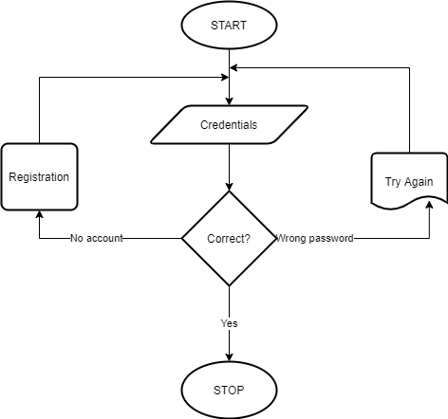

**3.5.4 REGISTRATION FLOWCHART**

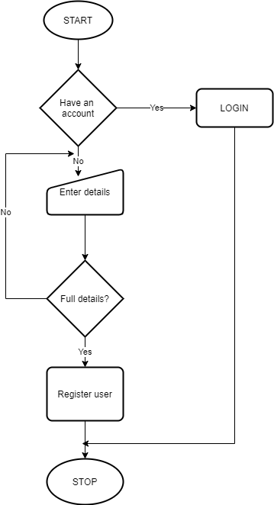

**3.5.5 BOOKING FLOWCHART**

3.6 DATABASE DESIGN

3.6.1 ENTITY RELATIONSHIP DIAGRAM

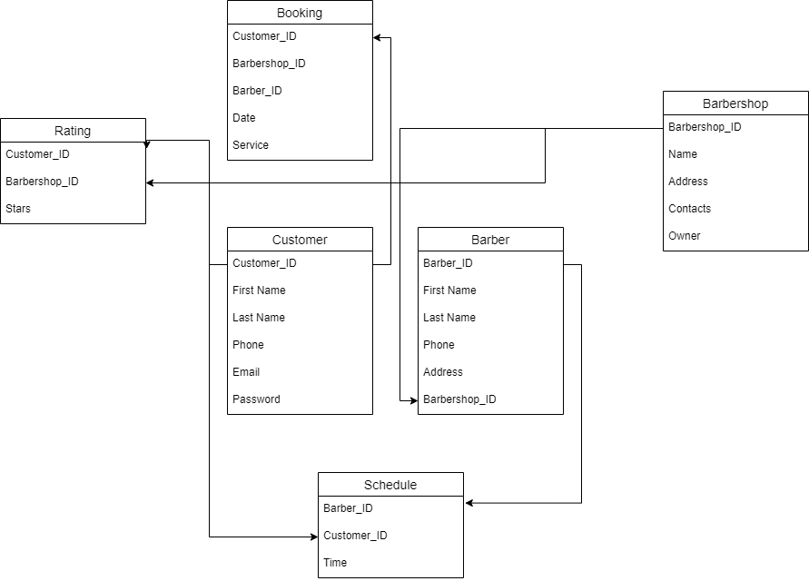

3.7 USER INTERFACE DESIGN

3.7.1 LOGIN DESIGN

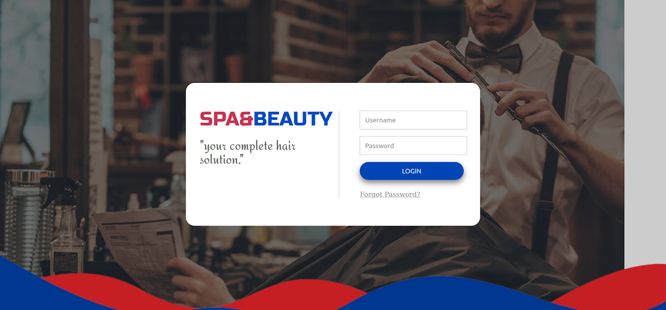

3.7.2 REGISTRATION DESIGN

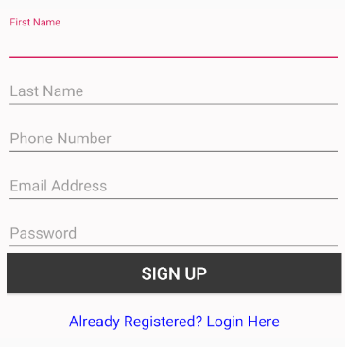

3.7.3 BOOKING INTERFACE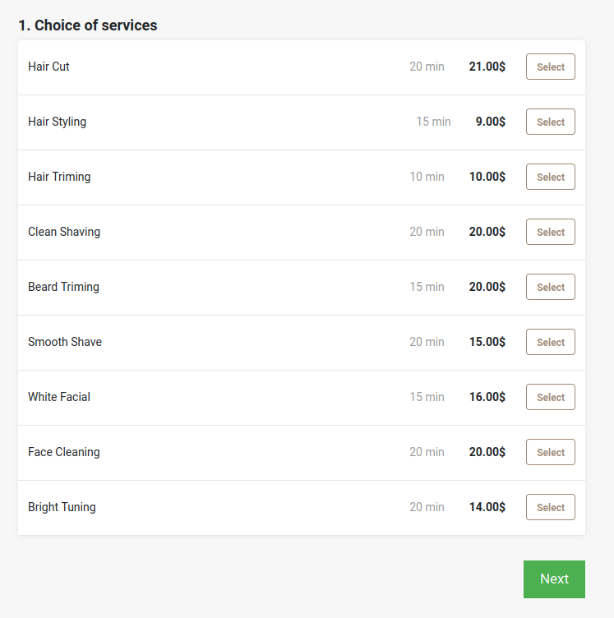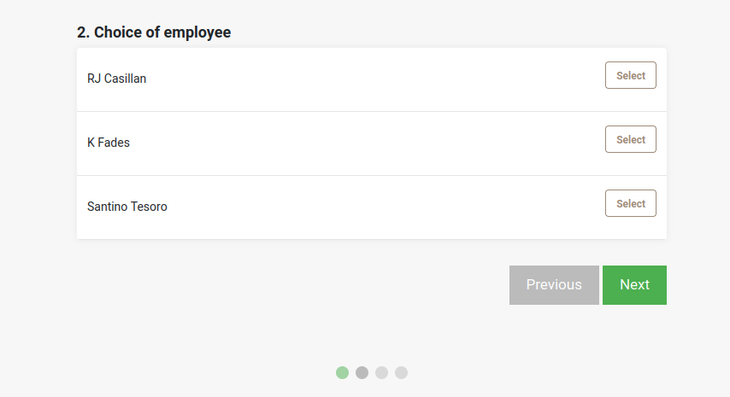

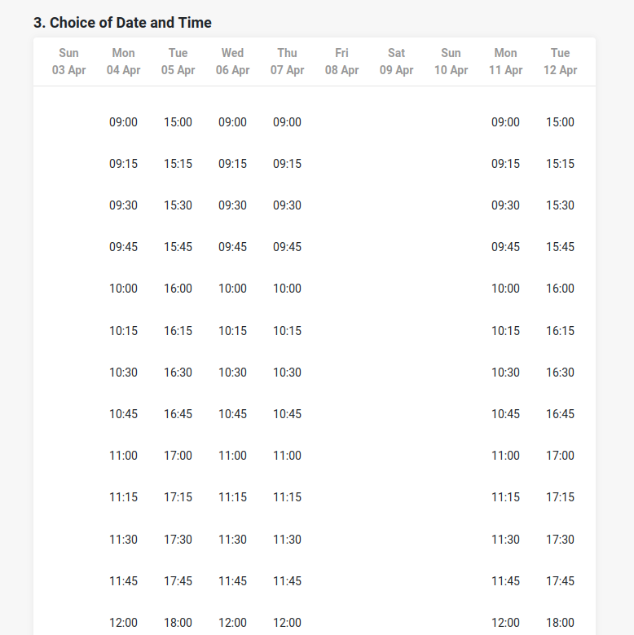

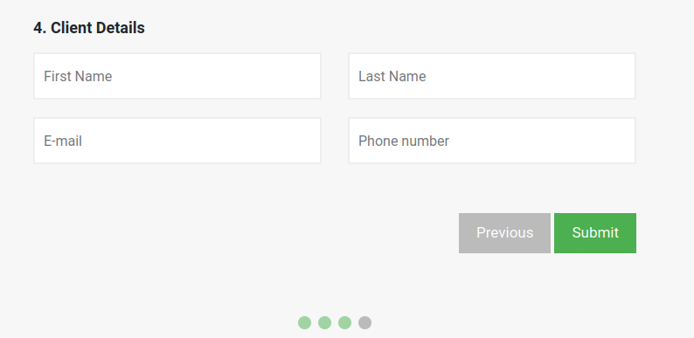

**3.8 IMPLEMENTATION AND TESTING**

After the code was written it needed to be tested to ensure there are no logical errors that could prevent the system to be integrated with another or different modules.

**3.8.1 RESOURCES**

**3.8.1.1 HARDWARE RESOURCES**

1. HP Notebook
2. Intel Core i5
3. 4 GB RAM
4. 500 GB HDD

3.8.1.2 SOFTWARE RESOURCES

1. Visual studio code
2. XAMPP
3. MYSQL

**3.8.2 CHOICE OF PROGRAMMING TOOLS AND TECHNIQUES**

1. JavaScript – JavaScript is a general-purpose programming language that is class-based, object-oriented, and designed to have as few implementation dependencies as possible. It is intended to let application developers write once, run on web browsers.
2. MYSQL - MySQL is a relational database management system (RDBMS) developed by Oracle that is based on structured query language (SQL).
3. HTML - This is a mark-up language used to design web applications
4. CSS - This is a cascading style sheet used to style the web application.

**3.8.3 TEST CASE**

- A test case is a set of actions executed to verify a particular feature or functionality of your software application.

TEST CASE FOR LOGIN

|  |  |  |  |
| --- | --- | --- | --- |
| **SCENARIO** | **EMAIL** | **PASSWORD** | **EXPECTED RESULT** |
| Correct variable entered | testapp@gmail.com | testapp2022 | Login successful |
| Wrong variables entered | testapp123@gmail.com | testapp2010 | Login failed |

**3.9 INTEGRATION**

This is used to find errors in current integration. This involved taking a particular module and inspecting the functional requirements

**4.0 CHAPTER 4: DISCUSSION AND CONCLUSION**

**4.1 ACHIEVEMENTS**

The project was successfully completed and after its implementation, the following objectives were achieved:

1. Users can register into the system
2. Users can login into the system
3. Users can book for services
4. Users can schedule appointments
5. Users can choose their preferred barber
6. Users can rate a barber after services are offered
7. Users can get a report after services have been offered to them

**4.2 CONSTRAINTS**

1. The system is reliant on internet connectivity
2. The barber’s schedule might change after a user has booked an appointment
3. Customers who walk into the barbershop directly instead of booking might inconvenience the booking system

4.3 CONCLUSION

- Despite the many challenges and few limitations associated with the system, it is evident that the system requirements were adequately met.

APPENDIX A: REFERENCES

<https://joon.co.ke/executive-barber-shop/>.

<https://en.wikipedia.org/wiki/Body_grooming>